Producer Application Installation Guide

# 1. Summary

The Producer Application is at the centre of the whole ProductChain. It is responsible for creating new QR codes to stick on products and moving products between different producers.

# 2. Requirements

* Android 6.0 or newer
* Application size: 2.81MB
* Phone must have Bluetooth
* Phone must have an internet connection.
* All servers and blockchain nodes must be operational before the ProducerApplication can be used.
* Bluetooth Beacon to move products

## 2.1 Permissions

* android.permission.ACCESS_NETWORK_STATE
* android.permission.INTERNET
* android.permission.WRITE_EXTERNAL_STORAGE
* android.permission.BLUETOOTH
* android.permission.BLUETOOTH_ADMIN

# 3. Installation guide

1. Open the Producer Application project in Android Studio

2. Update the NXT_BLOCKCHAIN_REMOTE variable to reflect the remote NXT blockchain address

3. Update the NXT_BLOCKCHAIN_LOCAL variable to reflect the local NXT blockchain address

4. Update the CACHING_SERVER variable to reflect the caching server address

5. Update the VERIFICATION_SERVER variable to reflect the verification server address

6. Update the QR_CODE_GEN_SERVER variable to reflect the QR code generating server address

7. Update the PRODUCT_CHAIN_NXT_ADDR variable to reflect the Product Chain NXT address.

8. Run the application to install it to the Android Device.

# 4. Display Sequence

## Task 1 – Create new Product QR code

Step 1. Open the application and select *Request new QR code*.

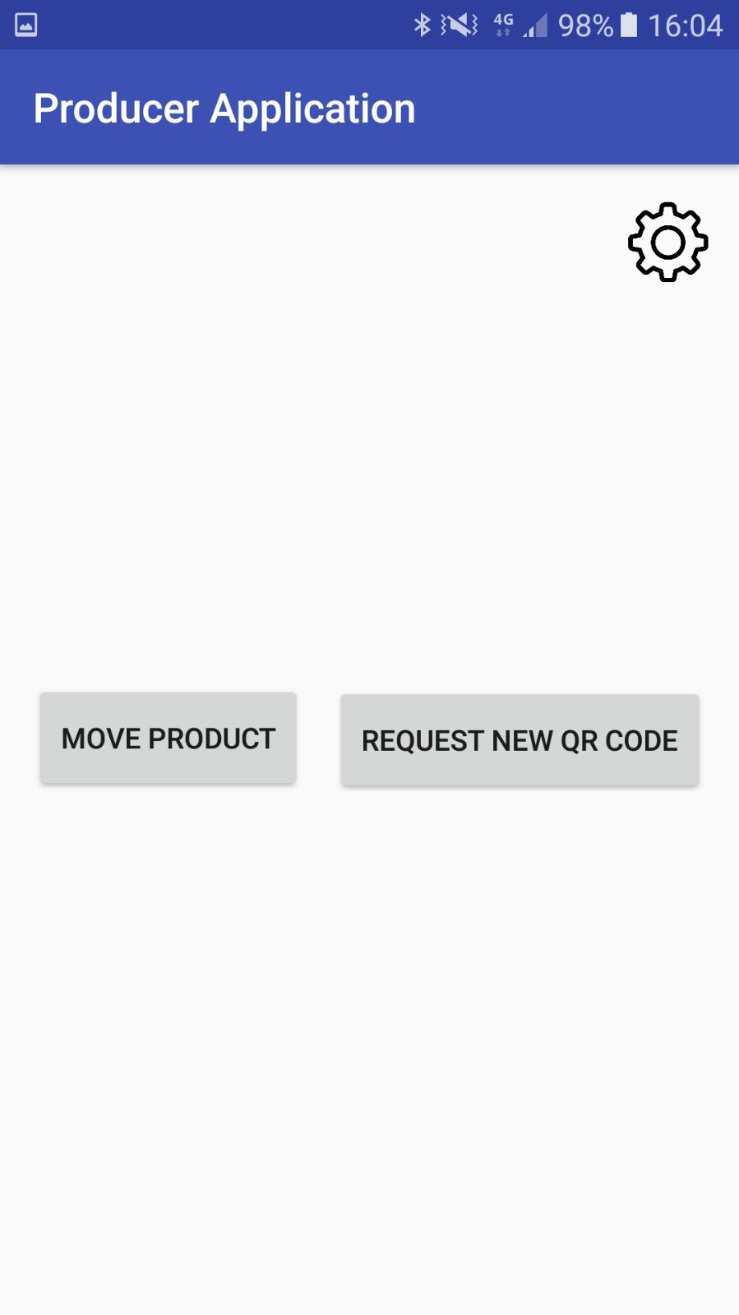

Step 2.